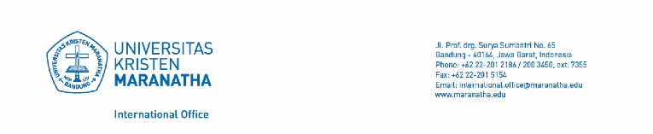

APPLICATION FORM FOR ADMISSON OF FOREIGN STUDENTS

Apply for : Exchange Program
Non-Exchange Program
Live In Program
Period :
(Odd semester – commencing in August)
(Even semester – commencing in January)

This form should be completed by the applicant in English

Affix Passport Size Color Photo Here

SECTION 1 PERSONAL INFORMATION

Name | Surname :
Name | Given name :
Gender | Male  Female |  | Nationality
Date of Birth (dd/mm/yyyy) |  |  | Place of Birth
Parent’s Name |  |  | Parent’s Occupation
Passport No |  |  | Expired date
Home Address (incld. Zip Code)

Telephone No.  Cellphone No. |  | Fax |  | E-mail

SECTION 2 HOME INSTITUTION

Home Institution |  | Telephone
Institution Address |  | E-mail
Contact Person  Telephone No.  Email | Position
1 International Office Universitas Kristen Maranatha
SECTION 3 ACADEMIC INFORMATION

Level of Study Undergraduate  Graduate | Year of study 1st 2nd 3rd 4th  Other :
Area of Specialisation | Current GPA
Award | Expected of Graduation
Field of Study at Universitas Kristen Maranatha | Duration of study  From year month  To year month

SECTION 4 PROPOSED STUDY ABROAD PLAN

Academic Year | Anticipated date of arrival in Indonesia (dd/mm/yyyy)
Study duration at Universitas Kristen Maranatha  One semester (6 months)  Two semesters (1 year) | Commencement  1st Semester (August - December)  2nd Semester (February - June)
Do you need International Office to help you to find for your accommodation ? Yes No

If yes, please mention the name of the Dormitory that you prefer :
Cherry Home Residence ; Room Type :
Fulmar ; Room Type :
Pondokan 8 ; Room Type :

SECTION 5 INTENDED COURSES

1. Please refer to “Courses Offered” on the Universitas Kristen Maranatha website (http://www.maranatha.edu) for a list of English lecture courses. Prerequisites must be met before you will be accepted into some courses. You may also choose courses without prerequisite requirements.
2. You will need to study full time load – 15 credit units minimum and maximum of 18 credit units (this is stated in the course details)

2 International Office Universitas Kristen Maranatha
Note : Completion of this form does not automatically enroll or register you.
Please fill in according to the course code and title given.

Course Code | Course Title | Credit

SECTION 6 ENGLISH PROFICIENCY

Is English your first/main language ? Yes
No

IELTS Score TOEFL Score Other :

SECTION 7 CHECKLIST & DECLARATION

Applicant must submit the following documents with this form when applying :
1) The copy of passport
2) Photographs (3 copies with red background)
3) The Academic Transcript
4) Recommendation letter from your home institution
5) A fully completed Health Examination Report
6) A certified copy of IELTS/TOEFL/other English proficiency test result
7) An essay, explaining why the student interests to participate in this program (max. 2 pages)
I hereby affirm that
1. All the information given in this form is true and correct
2. I shall abide by the Indonesian laws and the regulations of the university.
Signature Date (dd/mm/yyyy)

Parent’s Signature Date (dd/mm/yyyy)

Please return the completed form with other application materials to:
international.office@maranatha.edu (by email for the scanned documents)

International Office, Universitas Kristen Maranatha,
Jl.Prof.drg.Surya Sumantri No.65, Gedung Administrasi Pusat, 6th floor, Bandung 40164, Indonesia
(by mail for the original copy documents)

3 International Office Universitas Kristen Maranatha

